Recruitment – Marketing and Events Manager
Following a recent company restructure to realign skills and service provision, we are now looking for someone to fill our new post of Marketing and Events Manager.
The Cheltenham Business Improvement District (BID) was established in 2016 and then renewed for a second term 2021 to 2026. The BID represents its 800 levy-paying businesses and operates on an annual budget of £600,000.
There is a small project team led by the Chief Executive, who in turn reports to a Board of Directors.
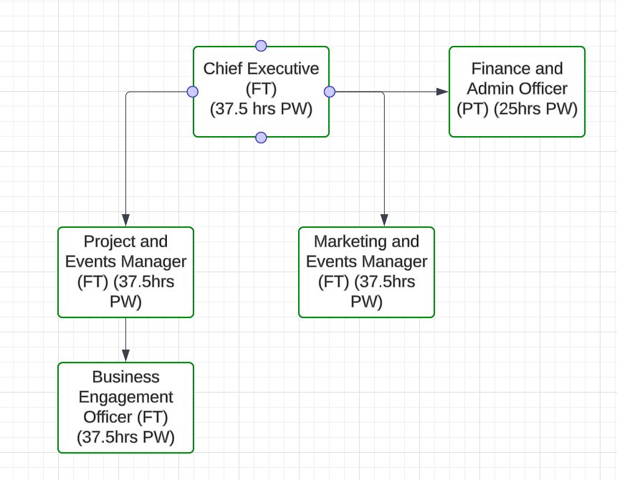
The full job description can be found below along with the relevant person specification. If you feel you do not meet all the requirements but have energy, enthusiasm and determination to do a good job, please do still contact us.
Applications
We welcome applications in the form of a covering letter and CV by email to recruitment@cheltenhambid.co.uk
The closing date for applications is 24 February 2025 and interviews are scheduled for 7 March 2024.
For more information on Cheltenham BID visit www.cheltenhambid.co.uk
For an informal chat about the role feel free to contact
Alex Rose, Chair of the BID alex.rose@beards.co.uk or
Dr Julie Grail, Consultant to the BID recruitment@cheltenhambid.co.uk

Marketing and Events Manager
Location: Cheltenham BID Office
Salary: £32,000 – £35,000
Job Summary:
The Marketing and Events Manager will lead and deliver Cheltenham BID’s marketing, communications, and promotional strategies to raise the profile of the BID, enhance the town’s attractiveness and support local businesses. This role is responsible for developing and managing campaigns, public relations activities, and events that engage the community, promote the BID’s initiatives, and drive footfall to the town.
Key Responsibilities:
- Marketing and Promotion: Develop and execute a comprehensive marketing strategy that supports the BID's business plan. Manage marketing campaigns across digital, print, and social media, oversee content creation for BID communications, and collaborate with local businesses on initiatives to boost visibility and footfall.
- Communications and PR: Develop and manage Cheltenham BID’s communication strategy to ensure clear and positive messaging. Collaborate with Visit Cheltenham and Marketing Cheltenham to promote the town efficiently. Foster relationships with media outlets to publicise BID activities, handle press enquiries, create media releases, and monitor and report on media coverage, creating a collaborative environment to ensure smooth project execution. Act as a key liaison between the BID and various community and business stakeholders.
- Digital Marketing and Social Media: Oversee Cheltenham BID’s digital presence, managing the website, social media, and email marketing. Create and schedule engaging content to promote BID activities and improvements and analyse digital metrics to enhance future campaigns and audience engagement.
- Events and Campaigns: Collaborate with the Project Manager and the BID team to plan, promote, and deliver events that align with BID objectives, attract visitors, and support local businesses. Develop partnerships with businesses, community groups, and stakeholders to maximize event success.
- Stakeholder Engagement: Cultivate strong relationships with key stakeholders to advance BID objectives. Engage regularly with BID members for feedback and collaboration and represent Cheltenham BID at meetings and events to raise awareness of its activities.
- Budget Management: Manage the marketing and communications budget to maximize ROI for BID members and regularly report on spending and campaign performance to the CE and BID Board.

Person Specification:
Essential Skills and Experience:
- Proven experience in marketing, communications, or public relations, ideally within a Business Improvement District, town centre, or destination marketing setting.
- Strong project management skills, with the ability to plan and execute multi-channel campaigns and events.
- Excellent written and verbal communication skills, with experience creating press releases, marketing content, and engaging social media posts.
- Ability to build relationships with stakeholders at all levels, including businesses, media, and local authorities.
- Experience managing social media platforms, brand management, digital marketing tools, and websites.
- Budget management experience, with the ability to deliver campaigns within budget.
Desirable Skills and Experience:
- Knowledge of Cheltenham and the local business environment.
- Experience working with public relations agencies or media outlets.
- Familiarity with digital marketing tools and analytics platforms (e.g., Google Analytics, Eventbrite, Mailchimp).
- Experience organising large-scale promotional campaigns.
Personal Attributes:
- Creative and innovative, with a passion for marketing and communications.
- Highly organised, with the ability to manage multiple projects simultaneously.
- Strong team player, with excellent interpersonal skills and the ability to collaborate across departments.
- Results-oriented, with a focus on delivering measurable outcomes for the BID and its businesses.

