Recruitment - Business Engagement Officer
Following a recent company restructure to realign skills and service provision, we are now looking for someone to fill our new post of Business Engagement Officer.
The Cheltenham Business Improvement District (BID) was established in 2016 and then renewed for a second term 2021 to 2026. The BID represents its 800 levy-paying businesses and operates on an annual budget of £600,000.
There is a small project team led by the Chief Executive, who in turn reports to a Board of Directors.
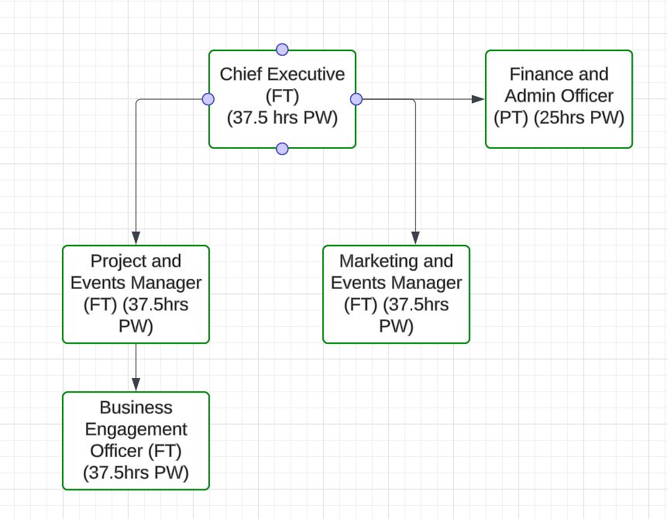
The full job description can be found below along with the relevant person specification. If you feel you do not meet all the requirements but have energy, enthusiasm and determination to do a good job, please do still contact us.
Applications
We welcome applications in the form of a covering letter and CV by email to recruitment@cheltenhambid.co.uk
The closing date for applications is 24 February 2025 and interviews are scheduled for 7 March 2024.
For more information on Cheltenham BID visit www.cheltenhambid.co.uk
For an informal chat about the role feel free to contact
Alex Rose, Chair of the BID alex.rose@beards.co.uk or
Dr Julie Grail, Consultant to the BID recruitment@cheltenhambid.co.uk

Business Engagement Officer
Location: Cheltenham BID Office
Salary: £24,000 – £27,000

Job Purpose:
The Business Engagement Officer will serve as the primary point of contact between Cheltenham BID and local businesses, fostering strong relationships and ensuring that the needs and concerns of BID members are addressed. This role will focus on building business engagement, facilitating communication between the BID and its members, and ensuring businesses are aware of and benefit from BID initiatives. The role also includes some responsibility for overseeing public realm improvements projects in collaboration with the wider BID team.
Key Responsibilities:
- Business Engagement and Support: Create strong, professional relationships with BID-area businesses through regular communication and engagement. Serve as a primary contact for our businesses, addressing concerns and sharing BID updates. Organise meetings and events, alongside colleagues, to promote collaboration and ensure business feedback informs BID projects.
- Liaison and Advocacy: Advocate for BID members in meetings with local authorities and stakeholders, representing their interests in policy and development discussions. Support businesses by connecting them with resources to overcome regulatory and operational challenges.
- Public Realm Oversight: Collaborate with the BID team and partners on public realm projects to enhance the town centre. Keep businesses informed and involved in initiatives and monitor the impact to ensure alignment with BID goals and local needs.
- Communication and Feedback: Ensure consistent communication between the BID and members through newsletters, updates, and meetings. Gather feedback on initiatives and improvements to represent business views, and report on engagement and suggestions to the Chief Executive and BID Board using the CRM system.
- Event and Campaign Support: Work with the Marketing and Events Manager to plan and promote initiatives that benefit local businesses, support campaigns to increase footfall, and coordinate business participation to maximise engagement and value.
- Relationship Building with Key Stakeholders: Build and maintain strong relationships with key external stakeholders, including local authorities, property owners, and business groups, to support the BID’s objectives and enhance Cheltenham’s business environment
- CRM Management: Update the CRM system to ensure all details are up to date.

Person Specification:
Essential Skills and Experience:
- Proven experience in business engagement, customer service, or community relations, ideally within a town centre, BID, or similar environment.
- Strong interpersonal and communication skills, with the ability to build rapport and maintain relationships with a wide range of stakeholders.
- Knowledge of business needs and challenges in a town centre or retail environment.
- Experience working in or with small and medium-sized enterprises (SMEs).
- Ability to manage multiple priorities and respond to the needs of businesses in a timely and efficient manner.

Desirable Skills and Experience:
- Understanding of public realm projects and their impact on business and community environments.
- Familiarity with Cheltenham’s business landscape and local economy.
- Experience working with local authorities, business associations, or other public/private sector partnerships.
- Project management skills related to the delivery of town centre or public space initiatives.
Personal Attributes:
- A proactive, professional and approachable individual who enjoys working with businesses and stakeholders.
- Strong problem-solving skills, with a focus on finding practical solutions to challenges faced by local businesses.
- Highly organised, with the ability to manage engagement activities and public realm projects concurrently.
- Self-motivated and driven to make a positive impact on Cheltenham’s business community.

